Online Forms

**Software Requirements Specification**

Version 1.0



**Group Id: S2302AB807 (Bc210201069)**

**Supervisor Name : Muhammad Saqib Javed**

**Revision History**

|  |  |  |  |
| --- | --- | --- | --- |
| **Date (dd/mm/yyyy)** | **Version** | **Description** | **Author** |
| 27/05/2023 | 1.0 | The project is a form generator like google forms in which the user can create maximum 10 forms and add multiple questions in it, The answers to those questions can be also viewed by the form creator in xl sheet. | Bc210201069 |
|  |  |  |  |
|  |  |  |  |
|  |  |  |  |

**Table of Contents**

1. Scope (of the project)
2. Functional Requirements Non Functional requirements
3. Use Case Diagarm
4. Work Plan (Use MS Project to create Schedule/Work Plan)

**SRS Document**

Scope of Project:

1. **Project Overview:** The "Online Form" project aims to develop a web application that allows users to create customizable forms and share them with others for data collection purposes. The project will replicate some functionalities of Google Forms while providing its unique features. The application will include secure user authentication, form creation, question types (such as text fields, dropdowns, checkboxes, and radio buttons), form submission deadlines, and result retrieval in an Excel sheet format.
2. **Project Objectives:** The main objectives of the project are as follows:

* Develop a web application that enables users to create and manage forms.
* Implement secure user authentication to ensure access control.
* Support different question types, including text fields, dropdowns, checkboxes, and radio buttons.
* Allow form creators to set submission deadlines for guest users.
* Store form responses in a database and provide form creators with access to the results.
* Generate an Excel sheet containing the form responses for easy analysis and reporting.
* Limit users to create a maximum of 10 forms.
* Limit the number of questions in each form to a maximum of 10.

1. **Deliverables:** The project will deliver the following components:

* User registration and login functionality.
* Form creation interface for form creators.
* Various question types (text fields, dropdowns, checkboxes, and radio buttons) for form customization.
* Form submission deadline functionality.
* Storage of form responses in a database.
* Result retrieval feature for form creators.
* Excel sheet generation with responses arranged in rows and questions as columns.
* Documentation describing the system architecture, installation process, and user guide.

1. **Scope Exclusions:** The following features and aspects are not included in the scope of this project:

* Advanced form customization options beyond the specified question types.
* Collaboration features for multiple form creators.
* Integration with external services or APIs.
* Advanced reporting and data analysis features.
* Mobile application development.
* Support for additional user roles beyond the form creator and guest user.
* Localization and multi-language support.

1. **Constraints:** The project must adhere to the following constraints:

* The project must be developed using modern web development technologies and tools.
* The application must support common web browsers.
* The project should be completed within the allocated time frame and available resources.
* The project must comply with security best practices for user authentication and data storage.

1. **Assumptions:** The following assumptions are made for the project:

* Users have basic knowledge of using web applications.
* Users have access to a compatible web browser.
* Users will be responsible for managing and maintaining their own form data.
* The application will be hosted on a web server accessible to users.

By defining the scope of the "Online Form" project, we establish a clear understanding of the project's objectives, deliverables, exclusions, constraints, and assumptions. This information will guide the development process and ensure that the project stays focused on meeting the specified requirements.

Functional and non Functional Requirements:

**Functional Requirements:**

1. **Secure Login:**

* Users must be able to create an account with a valid email address.
* The system should provide secure access with login credentials.
* User authentication should be implemented to ensure only authorized users can access the application.
* Passwords should be securely stored using encryption techniques.

1. **User Roles:**

* There are two user roles: Form Creator and Guest User.
* Form Creators can create and manage forms, set submission deadlines, and access form results.
* Guest Users are recipients of the forms and can fill out the forms without requiring a login.

1. **Form Creation:**

* Form Creators should be able to create up to 10 forms.
* The system should provide an intuitive interface for form creation, allowing the Form Creator to add, edit, and delete questions.
* Questions should support various types, including Short Answer, Long Answer, Dropdowns, Checkboxes, and Radio Buttons.
* Form Creators should have the ability to specify question requirements, such as mandatory fields or answer length limitations.

1. **Storage of Form Responses:**

* All form responses should be securely stored in a database.
* Each response should be associated with the corresponding form and guest user.
* Form Creators should have access to view and retrieve the form responses at any time.

1. **Results in Excel Format:**

* The system should generate an Excel sheet with the form responses.
* Each question should be represented as a column, and each guest response as a row in the Excel sheet.
* The Excel sheet should be easily downloadable and compatible with common spreadsheet applications.

**Non-functional Requirements:**

1. **Usability:**

* The user interface should be intuitive and user-friendly.
* Clear instructions and guidance should be provided for users in using the application.
* The application should have responsive design and work well on different screen sizes and devices.

1. **Performance:**

* The system should be able to handle multiple concurrent users without significant performance degradation.
* Forms should load quickly, and form submission and result retrieval processes should be efficient.

1. **Security:**

* The system should ensure the confidentiality and integrity of user data.
* Secure connections (HTTPS) should be used for data transmission.
* User passwords should be stored securely using strong encryption techniques.
* Proper input validation should be implemented to prevent common security vulnerabilities, such as SQL injection or cross-site scripting (XSS) attacks.

1. **Reliability:**

* The system should have high availability and minimal downtime.
* Regular data backups should be performed to prevent data loss.
* Error handling and logging should be implemented to facilitate troubleshooting and issue resolution.

1. **Compatibility:**

* The application should be compatible with popular web browsers such as Chrome, Firefox, and Safari.
* It should support multiple operating systems, including Windows, macOS, and Linux.

1. **Scalability:**

* The system should be designed to handle increasing data and user load in the future.
* It should be scalable to accommodate potential future enhancements and additional features.

By outlining the functional and non-functional requirements, we establish the desired functionality and qualities of the system. These requirements will guide the development process and ensure that the final product meets the expectations of the stakeholders.

Use Case Diagram

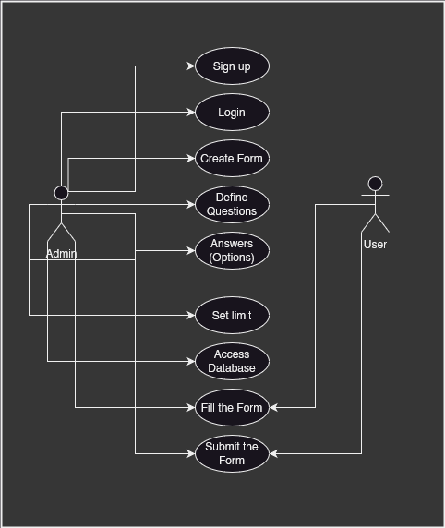

Work Plan (Use MS Project to create Schedule/Work Plan)

